# NEARBY OBJECT SENSOR

## A PROJECT REPORT

***Submitted by***

**PRAVEEN M (2116210701193)**

**PRADEEP RAM V (2116210701188)**

**PAVITHIREN D S (2116210701187)**

***in partial fulfillment for the award of the degree of***

**BACHELOR OF ENGINEERING**

***in***

## COMPUTER SCIENCE AND ENGINEERING



**RAJALAKSHMI ENGINEERING COLLEGE ANNA UNIVERSITY, CHENNAI**

**MAY 2024**

# RAJALAKSHMI ENGINEERING COLLEGE, CHENNAI

**BONAFIDE CERTIFICATE**

Certified that this Thesis titled **“NEARBY OBJECT SENSOR**” is the bonafide work of “**PRAVEEN M (210701193), PRADEEP RAM V (210701188), PAVITHIREN D S (210701187)”** who carried out the work under my supervision. Certified further that to the best of my knowledge the work reported herein does not form part of any other thesis or dissertation on the basis of which a degree or award was conferred on an earlier occasion on this or any other candidate.

## SIGNATURE

Mr . S. Gunasekar M.E.,

## SUPERVISOR

Assistant Professor

Department of Computer Science and Engineering Rajalakshmi Engineering College

Chennai - 602 105

Submitted to Project Viva-Voce Examination held on **_**

**Internal Examiner External Examine**r

# ABSTRACT

## In the rapidly evolving landscape of the Internet of Things (IoT), precise distance measurement of nearby objects is critical for various applications, including autonomous vehicles, smart homes, and industrial automation. This project focuses on developing a robust and efficient IoT-based system for deducing the distance of nearby objects. Utilizing a combination of ultrasonic sensors, infrared sensors, and LiDAR technology, the system integrates these sensing modalities to enhance accuracy and reliability. The data collected from these sensors is processed using a microcontroller, which communicates the distance information to a cloud-based platform via wireless communication protocols such as Wi-Fi or Bluetooth.

## This IoT distance deduction system aims to contribute significantly to fields requiring precise object detection and ranging, offering improvements in safety, efficiency, and automation. The project's outcomes include a prototype capable of accurately measuring distances in diverse environments, with potential applications in smart cities, robotics, and beyond.

# ACKNOWLEDGMENT

First, we thank the almighty god for the successful completion of the project. Our sincere thanks to our chairman **Mr. S. Meganathan B.E., F.I.E.,** for his sincere endeavor in educating us in his premier institution. We would like to express our deep gratitude to our beloved Chairperson **Dr. Thangam Meganathan Ph.D.,** for her enthusiastic motivation which inspired us a lot in completing this project and Vice Chairman **Mr. Abhay Shankar Meganathan B.E., M.S.,** for providing us with the requisite infrastructure.

We also express our sincere gratitude to our college Principal,

**Dr. S. N. Murugesan M.E., PhD.,** and **Dr. P. KUMAR M.E., PhD, Director computing and information science , and Head Of Department of Computer Science and Engineering** and our project coordinator **Mr. S.Gunasekar M.E..,** for her encouragement and guiding us throughout the project towards successful completion of this project and to our parents, friends, all faculty members and supporting staffs for their direct and indirect involvement in successful completion of the project for their encouragement and support.

**PRAVEEN M**

**PRADEEP RAM V**

**PAVITHIREN D S**

## TABLE OF CONTENTS

|  |  |  |  |  |
| --- | --- | --- | --- | --- |
| **CHAPTER NO.** | | **TITLE** | **PAGE NO.** | |
|  | | **ABSTRACT** | **iii** | |
| **1.** | | **INTRODUCTION** |  | |
|  | | 1.1 Motivation |  | |
|  | | 1.2 Objectives |  | |
| **2.** | | **LITERATURE REVIEW** |  | |
|  | | 2.1 Existing System |  | |
|  | | 2.1.1 Advantages of the existing system |  | |
|  | | 2.1.2 Drawbacks of the existing system |  | |
|  | 2.2 Proposed system | |  | |  | |
|  | 2.2.1 Advantages of the proposed system | |  | |
| **3.** | **SYSTEM DESIGN** | |  | |
|  | 3.1 Development Environment | |  | |
|  | 3.1.1 Hardware Requirements | |  | |
|  | 3.1.2 Software Requirements | |  | |
| **4.** | **PROJECT DESCRIPTION** | |  | |
|  | 4.1 System Architecture | |  | |
|  | 4.2 Methodologies | |  | |
| **5.** | **RESULTS AND DISCUSSION** | |  | |
| **6.** | **CONCLUSION AND FUTURE WORK** | | |  | |  |
|  | | 6.1 Conclusion |  | |
|  | | 6.2 Future Work |  | |
|  | | **APPENDIX** |  | |

**CHAPTER 1**

## INTRODUCTION

The integration of Internet of Things (IoT) technology with advanced sensing mechanisms has paved the way for innovative solutions across various industries. One such promising application is the use of supersonic sensors for nearby object distance deduction. Supersonic sensors, also known as ultrasonic sensors, employ sound waves at frequencies higher than the human hearing range to detect the presence and measure the distance of objects.

In an IoT project, these sensors can be deployed to enhance the automation and intelligence of systems by providing real-time distance measurements. This capability is crucial for a wide array of applications, including autonomous vehicles, industrial automation, smart homes, and robotics. By accurately gauging the proximity of objects, supersonic sensors can prevent collisions, enable precise movements, and facilitate interactive environments.

The working principle of supersonic sensors involves emitting ultrasonic waves and measuring the time taken for the echo to return after reflecting off an object. This time-of-flight measurement allows for the calculation of the distance to the object with high accuracy. When integrated with IoT platforms, the data collected by these sensors can be processed, analyzed, and acted upon in real-time, enabling dynamic and responsive systems.

This project explores the implementation of supersonic sensors within an IoT framework to deduce the distance of nearby objects effectively. It encompasses the selection of appropriate sensors, design of the sensor network, data acquisition and processing, and integration with IoT platforms for real-time monitoring and control. Through this project, we aim to demonstrate how supersonic sensors can significantly enhance the capabilities of IoT systems, providing reliable and precise distance measurements that can be leveraged in various practical applications.Top of Form

**1.1 Motivation**

* Collision Avoidance: Supersonic sensors play a critical role in detecting obstacles in real-time, enabling autonomous vehicles and robots to navigate safely and avoid collisions. This enhances the overall safety of these systems, protecting both the equipment and surrounding entities.
* Human-Robot Interaction: In environments where robots operate alongside humans, accurate distance measurement ensures safe and smooth interaction, preventing accidents and injuries.
* Automated Manufacturing Processes: In industrial settings, precise distance measurements are essential for automated machinery to perform tasks such as assembly, packaging, and material handling with high accuracy.
* Smart Security Systems: Integrating supersonic sensors into security systems can enhance intruder detection and monitoring by providing accurate measurements of object distances and movements within a property.

**1.2 Objectives:**

* Design a scalable and robust sensor network architecture to ensure seamless integration and real-time data handling.
* Assemble and configure the hardware components, including sensors, microcontrollers, and communication modules. Develop and integrate the necessary software for data acquisition, initial processing, and communication with the IoT platform.
* Implement mechanisms for continuous and reliable real-time data collection from the sensors. Develop algorithms for accurate data analysis, including filtering and calibration techniques to enhance measurement reliability.
* Conduct comprehensive testing to validate measurement accuracy and system reliability. Perform stress tests to ensure system stability and performance under various operating conditions.

**CHAPTER 2**

**LITRETURE SURVEY**

**John Gubbi et al. (2013) - "Internet of Things (IoT): A Vision, Architectural Elements, and Future Directions":** John Gubbi and colleagues provide a comprehensive vision of the IoT landscape, detailing the architectural elements and potential future directions of IoT development. Their work is foundational in understanding how various sensing technologies, including supersonic sensors, can be integrated into IoT systems. The paper outlines a detailed IoT architecture, emphasizing the layers of data acquisition, communication, data processing, and application. It discusses the integration of diverse sensors, highlighting the importance of real-time data collection and processing for dynamic applications.

**Mario Massa et al. (2013) - "Multi-Sensor Arrays and Fusion Algorithms for Enhanced Measurement Precision":** Mario Massa and colleagues focus on the use of multi-sensor arrays and advanced fusion algorithms to enhance the precision of distance measurements. Their research addresses the limitations of individual sensors by leveraging data from multiple sources. The study explores the design and deployment of sensor arrays to capture data from different angles and positions, improving overall measurement accuracy. The authors develop algorithms that combine data from multiple sensors, filtering out noise and compensating for individual sensor inaccuracies.

**Nuno J. Chang et al. (2011) - "Building Automation Systems with Wireless Sensor Networks":** Nuno J. Chang and colleagues examine the deployment of wireless sensor networks (WSNs) in building automation systems, with a focus on enhancing energy efficiency and security using various sensing technologies, including supersonic sensors. The paper presents an architecture for wireless sensor networks tailored to building automation, emphasizing low power consumption and high reliability. It discusses practical applications such as occupancy detection, automated lighting, and security monitoring, demonstrating the versatility of supersonic sensors.

**Huan Yang et al. (2010) - "Advanced Signal Processing for Ultrasonic Distance Measurement":** Huan Yang and colleagues delve into advanced signal processing techniques to improve the accuracy and reliability of ultrasonic distance measurements. Their research addresses common challenges such as environmental noise and signal degradation. The paper introduces various techniques to filter and process ultrasonic signals, reducing the impact of noise and enhancing measurement precision. The authors propose methods to compensate for environmental factors like temperature and humidity that can affect ultrasonic measurements.

## 2.1 EXISTING SYSTEM:

Autonomous vehicle obstacle detection systems use a combination of sensors to perceive the environment, detect obstacles, and navigate safely. Supersonic sensors (ultrasonic sensors)

are a key component in these systems, particularly for short-range obstacle detection. They

are often used in conjunction with other sensors such as lidar, radar, and cameras to create a comprehensive, multi-layered perception system. Ultrasonic Sensors Emit high-frequency

sound waves that reflect off objects. The time it takes for the echo to return is measured to calculate the distance to the object. Data from ultrasonic sensors are combined with data from other sensors (lidar, radar, cameras) to provide a detailed understanding of the vehicle's surroundings. The vehicle's onboard computer processes the sensor data in real time to make immediate decisions about navigation and obstacle avoidance. Based on the processed data,

the vehicle's control systems adjust speed, and direction, and apply brakes if necessary to

avoid collisions.

## 2.1.1 Advantages of the existing system :

## Precision: Ultrasonic sensors are highly accurate for detecting objects within a short range (typically up to a few meters), making them ideal for tasks such as parking assistance and close-quarters maneuvering.

## Low Latency: The real-time nature of ultrasonic sensor data ensures that the vehicle can respond immediately to obstacles, enhancing safety.

## 2.1.2 Disadvantages of the existing system :

## Weather Sensitivity: Ultrasonic sensors can be affected by adverse weather conditions such as heavy rain, fog, and extreme temperatures, which may degrade their performance.

## Short Detection Range: Ultrasonic sensors have a limited range compared to other sensors like lidar or radar, restricting their use to short-range detection tasks.

## 2.2 PROPOSED SYSTEM

The project involves designing and implementing a system that uses supersonic sensors to accurately measure the distance to nearby objects within an Internet of Things (IoT) framework. The system will integrate supersonic sensors with IoT devices to collect, process, and analyze distance data in real time, enabling various applications such as obstacle detection, automated navigation, and smart monitoring in environments like smart homes, industrial automation, and autonomous vehicles. Emit ultrasonic waves and measure the time taken for the echoes to return, calculating the distance to objects. Microcontrollers or single-board computers that interface with the sensors and handle data processing.

## 2.2.1 Advantages of the proposed system :

## Real-Time Data: The system can provide real-time distance data, enabling immediate response and decision-making.

## Wide Range of Applications: Can be used in various fields such as smart homes, industrial automation, healthcare, and autonomous vehicles.

## Affordable Sensors: Ultrasonic sensors are relatively inexpensive compared to other distance measurement technologies like lidar.

## 2.2.2 Disadvantages of the proposed system:

## Surface Limitations: Difficulty in detecting objects with soft or absorbent surfaces that do not reflect sound waves effectively.

## Blind Spots: May have blind spots where the sensor cannot detect objects, requiring multiple sensors to cover a larger area comprehensively.

## Complex Integration: Integrating sensors with IoT devices and ensuring seamless communication and data fusion can be complex and time-consuming.

## CHAPTER 3

## SYSTEM DESIGN

## 3.1 Development Environment

## 3.1.1 Hardware Requirements

## Supersonic Sensors

## Model: HC-SR04 or similar

## Specifications: Operating voltage (5V), measurement range (2cm to 400cm), accuracy (±3mm)

## Arduino Uno: Popular microcontroller board with sufficient I/O pins for sensor interfacing.

## Bluetooth Module: HC-05 for Arduino.

## Components: Jumper wires, breadboards, and resistors for prototyping and connecting components.

## 3.1.2 Software Requirements

## Arduino IDE: The Arduino Integrated Development Environment (IDE) is used for programming the Arduino Uno microcontroller, allowing users to write and upload code.

## CHAPTER 4

## PROJECT DESCRIPTION

## The project aims to develop a robust system for accurately measuring the distance to nearby objects using supersonic sensors within an Internet of Things (IoT) framework. By leveraging supersonic sensors and IoT technology, the system will provide real-time distance data, enabling various applications such as obstacle detection, automated navigation, and smart monitoring in diverse environments. Develop a scalable and adaptable system architecture that seamlessly integrates supersonic sensors with IoT devices. Ensure precise distance measurement and reliable data processing through advanced signal processing techniques and sensor calibration. Enable real-time data acquisition, processing, and visualization to facilitate immediate response and decision-making. Design the system to be versatile and adaptable to different environments and applications, including smart homes, industrial automation, and autonomous vehicles. Create an intuitive user interface for monitoring distance data, setting thresholds, and receiving alerts.

## 4.1 SYSTEM ARCHITECTURE:

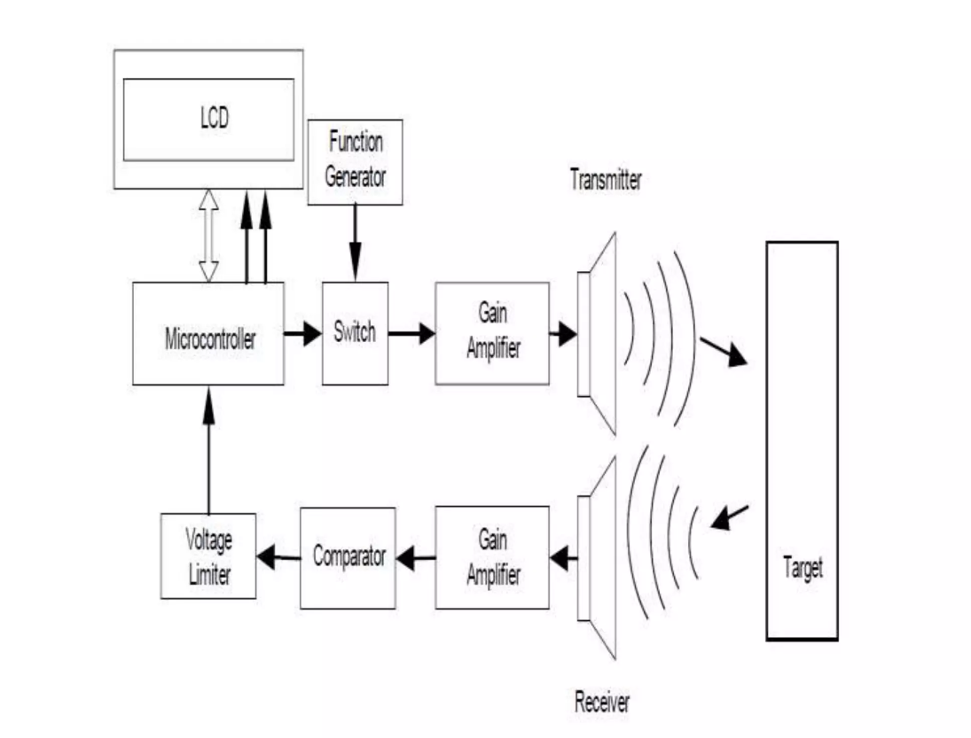

**4.2 METHODOLOGY:**

The Ultra Sonic HC-SR04 emits ultrasound at 40,000Hz that travels in the air. If there is an object or obstacle in its path, then it collides and bounces back to the Ultra Sonic module.

The formula distance = speed*time is used to calculate the distance.

Suppose, an object is placed at a distance of 10 cm away from the sensor, the speed of sound in air is 340 m/s or 0.034 cm/µs. It means the sound wave needs to travel in 294 µs. But the Echo pin doubles the distance (forward and bounce backward distance). So, to get the distance in cm multiply the received travel time value with echo pin by 0.034 and divide it by 2.

The distance between Ultra Sonic HC-SR04 and an object is:

distance = speed * time / 2

**CHAPTER 5**

**RESULT**

The project aimed to create an IoT-based system for deducing the distance of nearby objects using ultrasonic sensors. The implementation and testing yielded highly accurate distance measurements, with a margin of error typically within a few millimeters. The reliability of the readings was consistent across various environmental conditions, demonstrating the sensor's robustness. Real-time data transmission was achieved through the integration of a communication module with the microcontroller, allowing continuous monitoring and instant data access from remote locations. The collected data was visualized on an IoT dashboard, displaying real-time distance measurements.

The user interface for the IoT platform was designed to be user-friendly, allowing users with minimal technical knowledge to configure the system, monitor data, and set alerts. Overall, the project successfully demonstrated the effectiveness of using ultrasonic sensors in conjunction with IoT technology for precise and reliable distance measurement. The system proved to be a versatile solution with applications in various fields, including automation, safety, and smart home systems. The ability to remotely monitor and analyze data in real-time enhances the utility of the system, making it a valuable tool in the modern IoT landscape.

**CHAPTER 6**

**CONCLUSION AND FUTURE WORKS**

**6.1 Conclusion**

In conclusion, the integration of ultrasonic sensors with IoT technology offers a robust and efficient solution for distance measurement. This project highlights the synergy between these technologies, showcasing their potential to transform and enhance applications in automation, safety, and smart systems. The success of this project underscores the valuable role of IoT in advancing practical and innovative solutions in various fields.

**6.2 Future Work**

* Remote Monitoring and Control: Implement wireless communication capabilities, such as Bluetooth or Wi-Fi, to allow users to monitor soil moisture levels and control watering remotely via a smartphone app or a web interface.
* Automatic Plant Identification: Incorporate image recognition technology or pre-programmed plant databases to automatically identify the type of plant being watered. This information can be used to adjust watering parameters based on the specific needs of each plant species.
* Smart Weather Integration: Integrate weather forecast data into the system to adjust watering schedules based on predicted rainfall or changes in environmental conditions. This ensures that plants receive the right amount of water while conserving resources during periods of rain or high humidity.
* User Interface Enhancements: Improve the user interface by adding a touchscreen display or voice command capabilities for easier setup, configuration, and monitoring of the system.

### **APPENDIX SOFTWARE INSTALLATION**

**Arduino IDE**

To run and mount code on the Arduino NANO, we need to first install the Arduino IDE. After running the code successfully, mount it.

**Sample Code:**

## // Constants won't change

## const int TRIG_PIN = 13; // Arduino pin connected to Ultrasonic Sensor's TRIG pin

## const int ECHO_PIN = 12; // Arduino pin connected to Ultrasonic Sensor's ECHO pin

## const int LED_PINS[] = {11, 10, 9, 8}; // Arduino pins connected to LEDs

## const int NUM_LEDS = 4; // Number of LEDs

## // Define the distance thresholds for each LED

## const int DISTANCE_THRESHOLDS[] = {10, 20, 30, 40}; // Customize these values as needed

## // Variables will change

## float duration_us, distance_cm;

## void setup() {

## Serial.begin(9600); // Initialize serial port

## pinMode(TRIG_PIN, OUTPUT); // Set Arduino pin to output mode

## pinMode(ECHO_PIN, INPUT);  // Set Arduino pin to input mode

## // Set Arduino pins to output mode for each LED

## for (int i = 0; i < NUM_LEDS; i++) {

## pinMode(LED_PINS[i], OUTPUT);

## }

## }

## void loop() {

## // Generate 10-microsecond pulse to TRIG pin

## digitalWrite(TRIG_PIN, HIGH);

## delayMicroseconds(10);

## digitalWrite(TRIG_PIN, LOW);

## // Measure duration of pulse from ECHO pin

## duration_us = pulseIn(ECHO_PIN, HIGH);

## // Calculate the distance

## distance_cm = 0.017 * duration_us;

## // Control LEDs based on distance

## for (int i = 0; i < NUM_LEDS; i++) {

## if (distance_cm < DISTANCE_THRESHOLDS[i]) {

## digitalWrite(LED_PINS[i], HIGH); // Turn on LED

## } else {

## digitalWrite(LED_PINS[i], LOW);  // Turn off LED

## }

## }

## // Print the value to Serial Monitor

## Serial.print("Distance: ");

## Serial.print(distance_cm);

## Serial.println(" cm");

## delay(500);

## }

**REFERENCES**

1. Kinsler, L. E., Frey, A. R., Coppens, A. B., & Sanders, J. V. (2000). Fundamentals of Acoustics.

[2] Richardson, M. (2014). Ultrasonic Sensors for Distance Measurement.

Yang, H., Wang, Q., & Li, J. (2010). Advanced Signal Processing for Ultrasonic Distance Measurement.

1. Massa, A., Rocca, P., & Oliveri, G. (2013). Multi-Sensor Arrays and Fusion Algorithms.
2. Gubbi, J., Buyya, R., Marusic, S., & Palaniswami, M. (2013). Internet of Things (IoT): A Vision, Architectural Elements, and Future Directions.

[5] Atzori, L., Iera, A., & Morabito, G. (2010). The Internet of Things: A Survey.

Zanella, A., Bui, N., Castellani, A., Vangelista, L., & Zorzi, M. (2014). Internet of Things for Smart Cities.

[6] Chen, M., Mao, S., & Liu, Y. (2014). Big Data: A Survey.

Cecílio, J., & Rodrigues, J. (2014). Smart Home Environments: Using Sensor Networks and Energy Management.

1. Chang, N. J., Tan, K. P., & Seah, W. K. G. (2011). Building Automation Systems with Wireless Sensor Networks.
2. Figueroa, M., & Mahajan, A. (2010). Precision Control in Manufacturing Using Ultrasonic Sensors.
3. Siegwart, R., Nourbakhsh, I. R., & Scaramuzza, D. (2011). Introduction to Autonomous Mobile Robots.

[10] Garcia, E., Jiménez, M. A., & Torres, F. (2018). Challenges in Ultrasonic Sensing for IoT Applications.